CREATE STATEMENTS (PRIMARY AND FOREIGN KEYS ADDED IN CREATE STATEMENTS ONLY)
// CREATE TABLE ADDRESS
CREATE TABLE Address (
AddressID VARCHAR(50) NOT NULL,
Address1 VARCHAR(100) NOT NULL,
Address2 VARCHAR(100),
City VARCHAR(20) NOT NULL,
State VARCHAR(20) NOT NULL,
Zip VARCHAR(10) NOT NULL,
PRIMARY KEY(AddressID)
);

// CREATE TABLE Employee
CREATE TABLE Employee (
EmployeeID VARCHAR(50) NOT NULL,
FirstName VARCHAR(100) NOT NULL,
LastName VARCHAR(100) NOT NULL,
SSN VARCHAR(20) NOT NULL,
Phone VARCHAR(10) NOT NULL,
Email VARCHAR(100) NOT NULL,
AddressID VARCHAR(50) NOT NULL REFERENCES Address(AddressID),
StartDate DATE NOT NULL,
EndDate DATE,
PRIMARY KEY(EmployeeID));
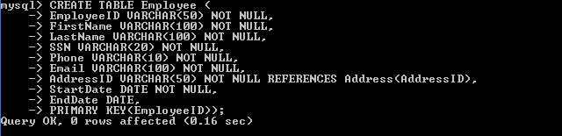
// CREATE TABLE CUSTOMER
CREATE TABLE CUSTOMER (
CustomerID VARCHAR(50) NOT NULL,
FirstName VARCHAR(100) NOT NULL,
LastName VARCHAR(100) NOT NULL,
Phone VARCHAR(10) NOT NULL,
Email VARCHAR(100) NOT NULL,
AddressID VARCHAR(50) NOT NULL REFERENCES Address(AddressID),
EmployeeID VARCHAR(50) NOT NULL REFERENCES Employee(EmployeeID),
PRIMARY KEY(CustomerID));
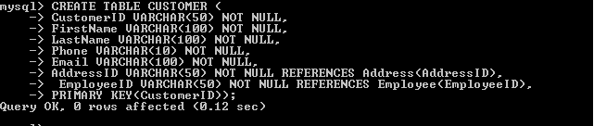
// CREATE TABLE CustomerFacing
CREATE TABLE CustomerFacing (
EmployeeID VARCHAR(50) NOT NULL REFERENCES Employee(EmployeeID),
ProductSpeciality VARCHAR(500) NOT NULL,
TrainingHours DECIMAL NOT NULL,
ComissionRate DECIMAL NOT NULL,
PRIMARY KEY(EmployeeID));
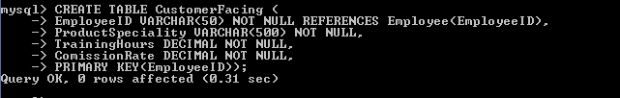
// CREATE TABLE InternalSupport
CREATE TABLE InternalSupport (
EmployeeID VARCHAR(50) NOT NULL REFERENCES Employee(EmployeeID),
Salary DECIMAL(10,2) NOT NULL,
SupportArea VARCHAR(200),
PRIMARY KEY(EmployeeID));
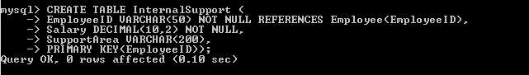
// CREATE TABLE Purchasers
CREATE TABLE Purchasers (
PurchaserID VARCHAR(50) NOT NULL,
CustomerID VARCHAR(50) NOT NULL REFERENCES Customer(CustomerID),
PRIMARY KEY(PurchaserID));
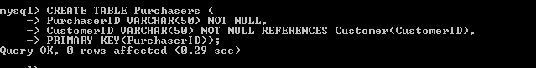

// CREATE TABLE Suppliers
CREATE TABLE Suppliers (
SupplierID VARCHAR(50) NOT NULL,
CustomerID VARCHAR(50) NOT NULL REFERENCES Customer(CustomerID),
PRIMARY KEY(SupplierID));
// CREATE TABLE PRODUCT
CREATE TABLE PRODUCT (
ProductID VARCHAR(50) NOT NULL,
Name VARCHAR(100) NOT NULL,
Color VARCHAR(10) NOT NULL,
Size INTEGER NOT NULL,
Price DOUBLE(10,2) NOT NULL,
Quantity DOUBLE(10,2) NOT NULL,
Description VARCHAR(500),
PRIMARY KEY(ProductID));
// CREATE TABLE Orders
CREATE TABLE Orders (
OrderID VARCHAR(50) NOT NULL,
PurchaserID VARCHAR(50) NOT NULL REFERENCES Purchaser(PurchaserID),
SupplierID VARCHAR(50) NOT NULL REFERENCES Supplier(SupplierID),
ProductID VARCHAR(50) NOT NULL REFERENCES Product(ProductID),
Date DATE NOT NULL,
Total DOUBLE(10,2) NOT NULL,
Resale DOUBLE(10,2) NOT NULL,
PRIMARY KEY(OrderID));

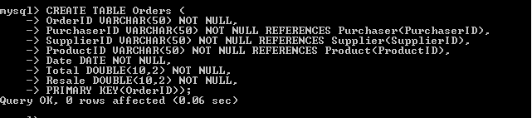

show tables;

Add data of 1 customer who buys from the company
INSERT into Address (AddressID,Address1,Address2,City,State,Zip) VALUES(
'2','58,East Street','Near CITI Bank','New York','US','190221');

INSERT into Customer (CustomerID,FirstName,LastName,Phone,Email,AddressID
,EmployeeID) values ('C01','Aliena','Cruz','9704679234','alina@gmail.com','2','E
01');

Add 1 employee who interacts with customers
INSERT into Address (AddressID,Address1,Address2,City,State,Zip) VALUES (
'1','234,Main Street','Near Linkin Park','New York','US','190221');

INSERT into Employee (EmployeeID,FirstName,LastName,SSN,Phone,Email,Addre
ssID,StartDate) values ('E01','Andrew','Smith','123456789','9478934666','andrew@
gmail.com','1','2014-05-02');

INSERT INTO CustomerFacing (EmployeeID,ProductSpeciality,TrainingHours,Co
missionRate) Values ('E01','Sales',12,2.5);

INSERT INTO InternalSupport (EmployeeID,Salary,SupportArea) values ('E01'
,250000,'Management');

INSERT INTO Purchasers(PurchaserID,CustomerID) VALUES ('P01','C01');

INSERT INTO Suppliers(SupplierID,CustomerID) VALUES ('S01','C01');

INSERT INTO Product(ProductID,Name,Color,Size,Price,Quantity,Description)
VALUES ('PP01','TShirt','Blue',40,2500,5,'Cool Lewis Tshirt');

INSERT INTO Orders(OrderID,PurchaserID,SupplierID,ProductID,Date,Total,Re
sale) values ('O01','P01','S01','PP01','2015-08-08',100,70);

Change data of the employee, giving the commission a 25% increase
UPDATE CustomerFacing SET ComissionRate = 1.25*ComissionRate;
Delete the customer and employee data
delete from customer;
delete from employee;

Select Statement to select the customer details
select * from customer;
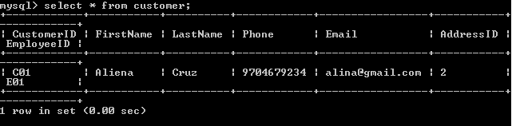
Select Statement to select the employee details
select * from employee;
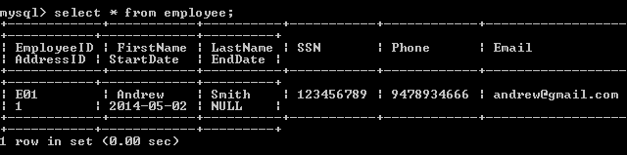

Select Statement to show which employee services which customer
select C.CustomerID,E.EmployeeID,E.FirstName as EmployeeFirstName,E.LastN
ame as EmployeeLastName from customer C inner join employee E on C.EmployeeID=E.
EmployeeID;

